Notes from SCIH Business Meeting at ICOH2015 Seoul, June 1 2015

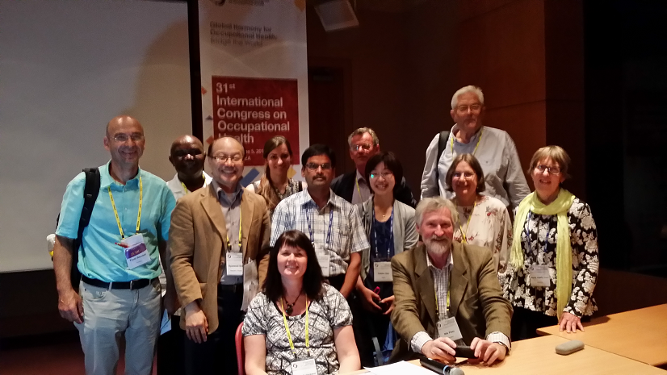
Picture from Hyunwook Kim

Names of attendes: Nils Plato, Sweden, Lena Andersson, Sweden, Marie Lewne, Sweden, Håkan Westberg, Sweden, Gerd Sällsten, Sweden, Rosa Orriols, Spain, Hyunwook Kim, Korea, Ayse Coskunerdev, Turkey, Yucel Demiral, Turkey, Yuikiko Iida, Japan, Ada Shehi, Albania, Agim Shehi, Albania, Deb Glass, Australia, Cherln Odhindo, Kenya, B Ravichandran, India.

As Chair and Secretary at the meeting Nils Plato and Lena Andersson were elected. Nils Plato explained the purpose for the Business Meeting and the roll for the Scientific Committee of Industrial Hygiene (SCIH) within the ICOH organisation. Both Chair and Secretary from SCIH attended the general assembly for the SCs on Saturday May 30. A part of the discussion at the assembly were concerns of how many SC there should be within ICOH, is it possible to merge some of the SC s together? From SC IH our opinion is to stay as a separat SC since IH is an occupation not an interest group.

The contributions from SCIH to this conference in Seoul are:
June 1, Oral session: Future Industrial Hygiene Expectations within Developing Countries
June 2, Special session: Occupational Exposure Limits and Sampling Strategy for Irregular & Intermittent tasks
June 2, APOSHO session: Industrial Hygiene
June 3, Oral session: Quantitative and Qualitative Exposures within Developed/Industrialized Countries
June 3, Oral session: Industrial Hygiene Hazard Management
June 1-4, Poster session: Poster Session Track B. Industrial Hygiene
June 1-4, Poster session: Student Poster Competition Track A. Industrial Hygiene

Coming conferences where SCIH can contribute or coorganize are:
Exposure assessment conference
Airmon, EPICOH, Toxicology
Rosa Orriols proposed two conferences in Spain.

Cooperation together with IOHA is crucial. Our contribution to IOHA could be that ICOH covers more countries than IOHA. IOHA have mostly English speaking member countries while ICOH covers most of the world.

SCIH has no own money but ICOH have a small budget were you can apply for travel funds.

Since Nils Plato is resigning as Chair in SCIH, Lena Andersson was voted as the new SCIH Chair for the coming triennium period and Hyunwook Kim was voted as the new SCIH Secretary.

The Midterm Meeting is not decided yet where it will take place. Next ICOH conference will be in Dublin 2018.

Nils Plato closed the meeting.

Lena Andersson
Secretary of the SCIH Business Meeting

